**Q. Define Effective Nuclear Charge and penetration of orbital’s?**

**Ans. The effective nuclear charge** is the net positive charge experienced by valence electrons.

It can be approximated by the equation: Zeff = Z – S,

Where Z is the atomic number and S is the number of shielding electrons.

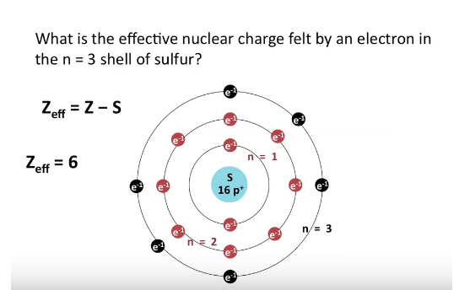

**Penetration of Orbital’s:** Penetration Power means the ability of an orbital to attract an electron. This process is accompanied with release of energy. The Penetration effect of s orbital is the maximum because of the closeness to the nucleus than are the p, d and f orbital's

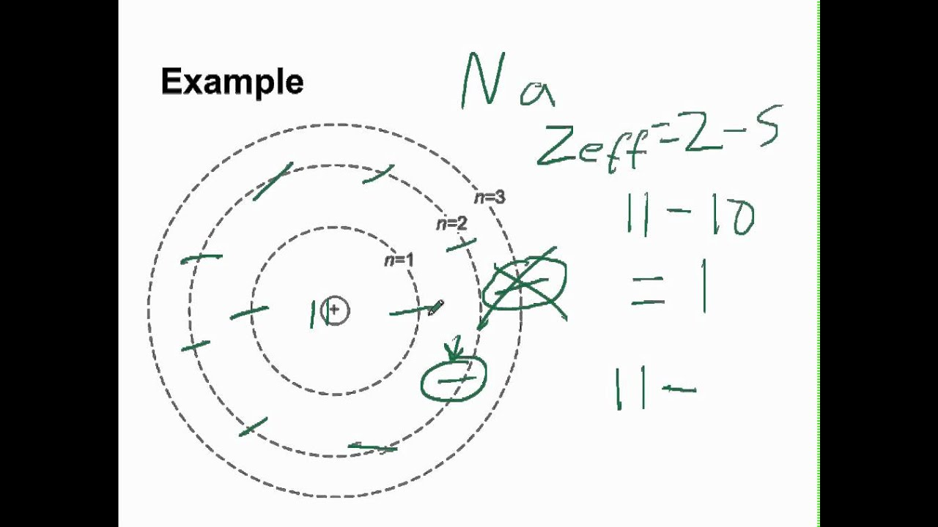

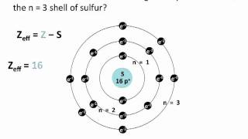

Penertration power

